3.29: Using the given values in Eq. (3.30),

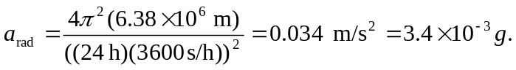
(Using the time for the siderial day instead of the solar day will give an answer that differs in the third place.) b) Solving Eq. (3.30) for the period T with 

